**Output #1**

HISTORICAL TIMELINE

|  |  |  |  |  |
| --- | --- | --- | --- | --- |
| **Types of Disaster** | **YOLANDA** | **EL NIÑO** | **TORNADO** | **LIGHTNING** |
| **Date of Major Occurrence** | *November 08, 2013* | *March – October 1982* | *August 13, 2014* | *February 2013* |
| **Impact and Strength** | *Supertyphoon* | *Drought* | *High Impact (Hail)* | *Medium Impact* |
| **Loss of Life/ Injured** | *1 dead*  *10 injured* | *None* | *None* | *2 injured* |
| **Property** | *16 houses partially damaged*  *139 houses totally damaged* | *None* | *20 houses partially damaged* | *1 house partially damaged*  *Most of the appliances were damaged* |
| **Infrastructures** | *Partially damaged – Barangay Hall, Learning Center, Daycare Center, Elementary School, Waiting Shed*  *Totally damaged – Stage, Streetlights, Chapel* | *3 jetmatic pumps dried up* | *None* | *Electric transformers were damaged* |
| **Agriculture** | *50 hectares rice fields destroyed*  *40 hectares coconut/banana plantation destroyed* | *50 hectares rice fields totally damaged*  *25 hectares banana plantation totally damaged* | *Rice fields and plants were damaged* | *None* |
| **Environment** | *30 hectares forest wiped out* | *Bodies of water dried up* | *40 hectares rice fields destroyed* | *None* |
| **Estimated Amount of Damage** | *P 20,000,000.00* | *P 2,500,000.00* | *P 200,000.00* | *P 200,000.00* |

**Output #1a**

HISTORICAL TIMELINE

**Output #2**

HAZARD MAP

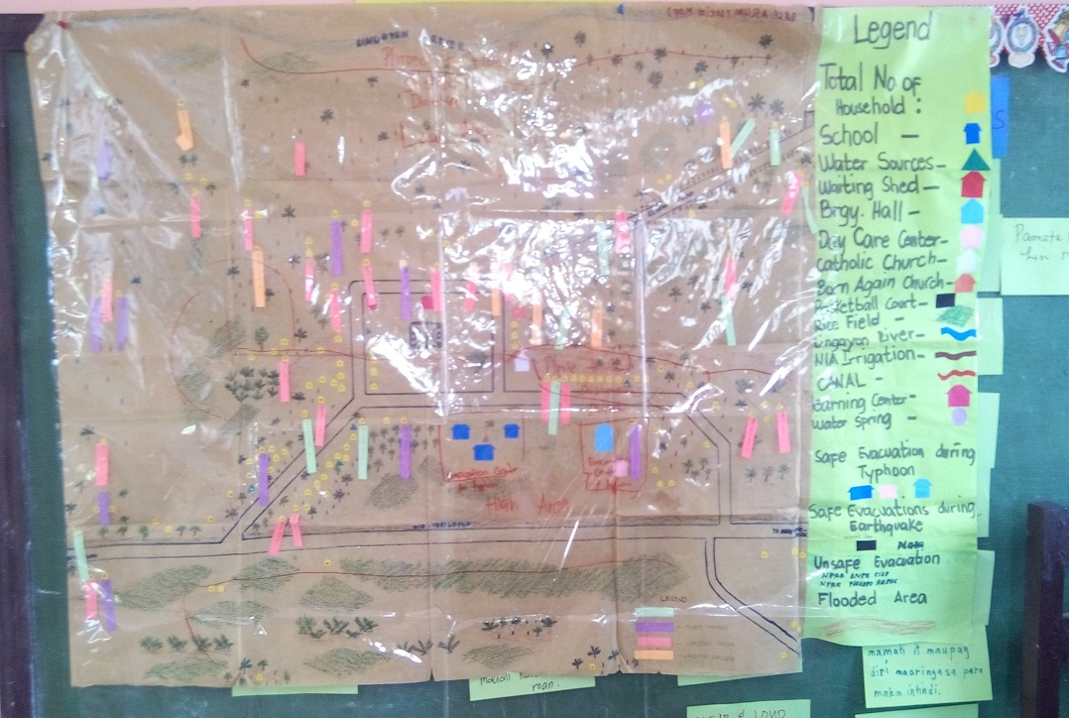

**Output #3**

RISK/VULNERABILITY ASSESSMENT

|  |  |  |  |  |
| --- | --- | --- | --- | --- |
| TYPES OF HAZARD | RISK | | | REASON |
| **LOW** | **MEDIUM** | **HIGH** |
| *Typhoon*  *(Yolanda)* |  |  | *X* | * *Houses have weak foundations because they are made up of light materials* * *Infrastructures also have weak foundations* * *People went hungry* * *People looted for goods for survival* * *People were traumatized* |
| *El Niño* |  |  | *X* | * *Most residents experienced hunger* * *Residents are fond of burning plastic* * *Long months went without rain* * *Plants and animals died* |
| *Tornado* |  |  | *X* | * *Most residents experienced trauma* * *Most houses were damaged* |
| *Lightning* |  | *X* |  | * *Only the appliances were damaged* |

**Output #5a**

VULNERABILITY and CAPACITY ANALYSIS

|  |  |  |  |
| --- | --- | --- | --- |
| Hazard Aspect  (El Niño) | Vulnerability | Capacities | Possible Action |
| Physical / Materials | *•Deep wells and water pumps easily dried up*  *•Plants and trees dried up; farm animals were also affected* | *•Residents had one source of water/”burabod”* | *•Construct a water pump or a deep well that is situated near the center of the barangay* |
| Social / Organizational | *•No organization could help the barangay find a solution to the loss of water during extreme droughts* | *•Willingness of the barangay to create and organize an organization that could help request for water pumps* | *•Construct additional water pumps that can be utilized by the whole barangay* |
| Motivational / Attitudinal | *•Residents are not working together to find an alternative source of water* | *•Some residents have already requested for water pumps* | *•Arrange for an awareness campaign which would seek to encourage the hunt for more possible sources of water* |

**Output #5b**

VULNERABILITY and CAPACITY ANALYSIS

|  |  |  |  |
| --- | --- | --- | --- |
| Hazard Aspect  (LIGHTNING) | Vulnerability | Capacities | Possible Action |
| Physical / Materials | *•Most households have electrical appliances*  *•The barangay is situated at an elevated/high area* | *•Each appliance is plugged to only one electric socket which prevents the flow of electric current* | *•During such times, residents should unplug their appliances and turn of the main switch* |
| Social / Organizational | *•People lack knowledge on what to do during lightning/when lightning strikes* | *•The people are very cooperative and willing to learn* | *•Plan and listen to weather forecasts/news advisory*  *•Be ready and alert* |
| Motivational / Attitudinal | *•People don’t usually unplug their electrical devices during lightning*  *•People tend to “overuse” their gadgets up to the point where they don’t mind even if lightning strikes* | *•People are aware that when lightning strikes, they should cover the things that could possibly attract it* | *•To be safe, all electrical appliances should be unplugged; people should also stay in safe places* |

**Output #5c**

VULNERABILITY and CAPACITY ANALYSIS

|  |  |  |  |
| --- | --- | --- | --- |
| Hazard Aspect  (TYPHOON) | Vulnerability | Capacities | Possible Action |
| Physical / Materials | *•Most houses are made up of light materials*  *•Not all houses are concrete*  *•Most of the houses don’t have sturdy posts* | *•Some concrete houses have strong foundation* | *•In the future, residents should construct sturdier posts and build a better housing foundation* |
| Social / Organizational | *•The barangay did not immediately gain access to relief items from different government and nongovernment organizations* | *•The barangay easily comes together in terms of asking for help from other organizations* | *•Identify organizations that could possibly help the barangay in times of disasters* |
| Motivational / Attitudinal | *•Most of the residents disregard notices from authorities to evacuate to safer places*  *•Other residents practice ignorance: even if they already know that a life threatening event is bound to happen, they don’t plan and prepare for it* | *•Some residents heed the call of the authorities to evacuate* | *•People should be made aware or be warned of upcoming typhoons* |

|  |  |  |  |  |  |  |  |  |  |  |  |  |
| --- | --- | --- | --- | --- | --- | --- | --- | --- | --- | --- | --- | --- |
|  | Livelihood | Water System | Sanitation | Evacuation Center | Agriculture | Health center w/ facilities | School | Shelter | Rehabilitation of drainage | C. R. | **Total** | Rank |
| Livelihood |  | 5 | 5 | 5 | 4 | 4 | 4 | 3 | 5 | 4 | 39 | 2nd |
| Water System | 1 |  | 3 | 1 | 1 | 1 | 3 | 1 | 1 | 2 | 14 | 9th |
| Sanitation | 1 | 2 |  | 1 | 1 | 1 | 1 | 1 | 1 | 1 | 10 | 10th |
| Evacuation Center | 1 | 5 | 5 |  | 1 | 1 | 4 | 1 | 1 | 1 | 20 | 6th |
| Agriculture | 1 | 5 | 5 | 5 |  | 4 | 5 | 1 | 1 | 3 | 30 | 3rd |
| Health center w/ facilities | 1 | 4 | 4 | 4 | 1 |  | 4 | 1 | 1 | 1 | 21 | 5th |
| School | 1 | 4 | 4 | 4 | 1 | 1 |  | 1 | 3 | 3 | 22 | 4th |
| Shelter | 3 | 5 | 5 | 5 | 3 | 5 | 5 |  | 5 | 5 | 41 | 1st |
| Rehabilitation of drainage | 1 | 3 | 3 | 2 | 1 | 3 | 3 | 1 |  | 3 | 20 | 7th |
| C. R. | 1 | 3 | 3 | 1 | 1 | 2 | 1 | 1 | 2 |  | 16 | 8th |

**Output #8**

PRIORITY MATRIX

**Output #9**

RESOURCE MATRIX

|  |  |  |  |  |  |
| --- | --- | --- | --- | --- | --- |
| **ACTIVITIES/ RESOURCES** | **HUMAN** | **FINANCE** | **SOCIAL** | **PHYSICAL** | **NATURAL** |
| SHELTER | **✓** | **🞪** | **🞪** | **✓** | **✓** |
| LIVELIHOOD | **✓** | **🞪** | **✓** | **✓** | **🞪** |
| AGRICULTURE | **✓** | **🞪** | **✓** | **✓** | **✓** |
| SCHOOL | **✓** | **🞪** | **✓** | **✓** | **✓** |
| HEALTH CENTER W/ FACILITIES | **✓** | **🞪** | **🞪** | **✓** | **🞪** |
| EVACUATION CENTER | **✓** | **🞪** | **🞪** | **✓** | **🞪** |
| REHABILITATION OF DRAINAGE | **✓** | **✓** | **✓** | **✓** | **🞪** |
| CR | **✓** | **🞪** | **✓** | **✓** | **✓** |
| WATER SYSTEM | **✓** | **✓** | **✓** | **✓** | **✓** |
| SANITATION | **✓** | **🞪** | **✓** | **✓** | **✓** |

COMMITTEE

|  |  |  |
| --- | --- | --- |
| LIVELIHOOD | SHELTER | WATER and SANITATION |
| Chairman: Antonio Teraza | Chairman: Hon. Thadeo Versoza | Chairman: Hon. Leah Vero  (09493796006) |
| Lorna Madrigal  (09095064531/09355121827) | Arnel Lazon  (09105305773) | Analyn Falguera  (09983766074) |
| Paz Cabelin  (09466644037) | Junely Justiza | Analisa Dolor  (09085781923/09355121350) |
| Marianita Catada  (09468567930) | Gemmalyn Madrigal  (09101429162) | Leah Lantajo  (09998371371) |
| Mary Ann Mahamis  (09481530602) | Efren Josol | Nelida Sales  (09051383301) |

**Output #7**

**Poverty experienced by residents of Barangay Aslum**

PROBLEM TREE

Difficult living conditions

Prevalence of different diseases

Not enough livelihoods

Lack of employment opportunities

Most of the houses are still damaged

No evacuation center people can run to during calamities

Low farm yield

Only 60% of the households have comfort rooms

Lack of supply for potable water

Flooding

Improper waste disposal

Lack of medicines; no emergency vehicle available in cases of emergency

Health center is far from the barangay

Destroyed drainage

Insufficient number of water pumps

People were not able to finish their schooling

No fertilizers used in rice fields

**Agriculture**

**Absence of an evacuation center**

**Shelter**

**Education**

**Livelihood**

**Health center with facilities**

**Water and Sanitation**

The school is far from the barangay

Financial problems

|  |  |  |  |  |  |  |  |  |  |  |  |  |
| --- | --- | --- | --- | --- | --- | --- | --- | --- | --- | --- | --- | --- |
| SEASONS  **Output #6**  SEASONAL CALENDAR | January | February | March | April | May | June | July | August | September | October | November | December |
| New Year’s Day |  |  |  |  |  |  |  |  |  |  |  |  |
| Women’s Day |  |  |  |  |  |  |  |  |  |  |  |  |
| Women’s Ass. Meeting |  |  |  |  |  |  |  |  |  |  |  |  |
| Farmer’s Association |  |  |  |  |  |  |  |  |  |  |  |  |
| Valentines Day |  |  |  |  |  |  |  |  |  |  |  |  |
| Planting season |  |  |  |  |  |  |  |  |  |  |  |  |
| Harvest season |  |  |  |  |  |  |  |  |  |  |  |  |
| Brgy. Assembly |  |  |  |  |  |  |  |  |  |  |  |  |
| Fiesta |  |  |  |  |  |  |  |  |  |  |  |  |
| Mass |  |  |  |  |  |  |  |  |  |  |  |  |
| Immunization |  |  |  |  |  |  |  |  |  |  |  |  |
| Semana Santa |  |  |  |  |  |  |  |  |  |  |  |  |
| Graduation |  |  |  |  |  |  |  |  |  |  |  |  |
| Pintakasi |  |  |  |  |  |  |  |  |  |  |  |  |
| Brigada eskwela |  |  |  |  |  |  |  |  |  |  |  |  |
| Mass treatment Schisto |  |  |  |  |  |  |  |  |  |  |  |  |
| Mother class |  |  |  |  |  |  |  |  |  |  |  |  |
| FDS (4P’s) |  |  |  |  |  |  |  |  |  |  |  |  |
| Fiesta minatay |  |  |  |  |  |  |  |  |  |  |  |  |
| Foundation day |  |  |  |  |  |  |  |  |  |  |  |  |
| Christmas |  |  |  |  |  |  |  |  |  |  |  |  |
| Rainy season |  |  |  |  |  |  |  |  |  |  |  |  |
| Dry season |  |  |  |  |  |  |  |  |  |  |  |  |
| Children’s Month |  |  |  |  |  |  |  |  |  |  |  |  |

**Output #6a**

SEASONAL CALENDAR LEGENDS

New Year’s Day

Women’s Day

Women’s Ass. Meeting

Farmer’s Association

Valentines Day

Planting season

Harvest season

Brgy. Assembly

Fiesta

Mass

Immunization

Semana Santa

Graduation

Pintakasi

Brigada eskwela

Mass treatment Schisto

Mother class

FDS (4P’s)

Fiesta minatay

Foundation day

Christmas

Rainy season

Dry season

Children’s Month

ACF

RHU

RED CROSS

PCA

DA

KALAHI CIDSS

MERCY CORPS

BLGU

4-Ps

**Output #4**

VENN DIAGRAM

4Ps

ACF

BLGU

DA

KALAHI-CIDSS

Mercy Corps

PCA

Red Cross

RHU

UNICEF

UNICEF

Save the Children

**Output #5d**

VULNERABILITY and CAPACITY ANALYSIS

|  |  |  |  |
| --- | --- | --- | --- |
| Hazard Aspect  (TORNADO/WHIRLWIND) | Vulnerability | Capacities | Possible Action |
| Physical / Materials | *•Most of the houses are made up of light materials* | *•Presence of residents who are skilled workers*  *•Availability of sources of materials that can be used to build more durable houses* | *•Plan to have a training to build sturdier houses* |
| Social / Organizational | *•Unavailability of devices that could detect upcoming tornadoes/whirlwind* | *•Residents are more than willing to help the barangay ask for assistance from responsible organizations* | *•Organize an awareness campaign and seminar on climate change* |
| Motivational / Attitudinal | *•Most of the residents lack knowledge in building sturdy houses* | *•Residents are willing to organize a seminar on how to mitigate the effects of such hazardous event* | *•Residents should have a first-hand experience or training on disaster risk reduction* |